Abstract

We propose a view-based approach to recognize humans from their gait. Two different image features have been considered: the width of the outer contour of the binarized silhouette of the walking person and the entire binary silhouette itself. To obtain the observation vector from the image features, we employ two different methods. In the first method, referred to as the indirect approach, the high- dimensional image feature is transformed to a lower dimensional space by generating what we call the frame to exemplar (FED) distance. The FED vector captures both structural and dynamic traits of each individual. For compact and effective
gait representation and recognition, the gait information in the FED vector sequences is captured in a hidden Markov model (HMM). In the second method, referred to as the direct approach, we work with the feature vector directly (as opposed to computing the FED) and train an HMM. We estimate the HMM parameters (specifically the observation probability ) based on the distance between the exemplars and the image features. In this way, we avoid learning high-dimensional probability density functions. The statistical nature of the HMM lends overall robustness to representation and recognition.

Introduction

Kinetic biometrics centre on supposedly innate, unique and stable muscle actions such as the way an individual walks, talks, types or even grips a tool. Those so-called behavioural measures have been criticised as simply too woolly for effective one to one matching, given concerns that they are are not stable (for example are affected by age or by externals such as an individual's health or tiredness on a particular day),

- are not unique

- or are simply to hard to measure in a standard way outside the laboratory (with for example an unacceptably high rate of false rejections or matches because of background noise or poor installation of equipment).

Proponents have responded that such technologies are non-intrusive, are as effective as other biometrics or should be used for basic screening (for example identifying 'suspects' requiring detailed examination) rather than verification.

Signature verification (ie comparing a 'new' signature or signing with previously enrolled reference information) takes two forms: dynamic signature verification and analysis of a static signature that provides inferential information about how the paper was signed. It can be conducted online or offline.

Dynamic Signature Verification (DSV) is based on how an individual signs a document - the mechanics of how the person wields the pen - rather than scrutiny of the ink on the paper.

Advocates have claimed that it is the biometric with which people are most

comfortable (because signing a letter, contract or cheque is common) and that although a might be able to achieve the appearance of someone's signature it is impossible to duplicate the unique 'how' an individual signs. Critics have argued that it provides a blurry measure, with an inappropriate percentage of false rejects and acceptances.

DSV schemes typically measure speed, pen pressure, stroke direction, stroke length and points in time when the pen is lifted from the paper or pad. Some schemes require the individual to enrol and thereafter sign on a special digital pad with an inkless pen. Others involve signing with a standard pen on paper that is placed over such a pad. More recently there have been trials involving three- dimensional imaging of the way that the individual grasps the pen and moves it across the paper in signing, a spinoff of some of the facial biometric schemes discussed earlier in this note.

In practice there appears to be substantial variation in how individuals sign their names or write other text (particularly affected by age, stress and health). Systems have encountered difficulties capturing and interpreting the data. In essence, the mechanics of signing are not invariant over time and there is uncertainty in matching.

Some signature proponents have accordingly emphasised static rather than dynamic analysis, examining what an image of a signature tells about how it was written. Typically it uses high-resolution imaging to identify how ink was laid down on the paper, comparing a reference signature with a new signature. In

practice the technology does not perform on a real time basis and arguably should not be regarded as a biometric, with proponents having sought the biometric label on an opportunistic basis for marketing or research funding.

DSV systems have reflected marketing to the financial sector and the research into handwriting recognition that has resulted in devices such as the Newton, Palm and Tablet personal computer. Although there are a large number of patents and systems are commercially available uptake has disappointed advocates, with lower than expected growth and - more seriously - the abandonment by major users of the technology.

Keystroke dynamics uses the same principles as dynamic signature verification, offering a biometric based on the way an individual types at a keyboard.

In essence, the keystroke or 'typing rhythm' biometric seeks to provide a signature

- ie a unique value - based on two time-based measures -

- dwell time - the time that the individual holds down a specific key

- flight time - the time spent between keys

with verification being provided through comparison with information captured during previous enrolment.

Typically development of that reference template involves involves several sessions where the individual keys a page or more of text. Claims about its effectiveness differ; most researchers suggest that it is dependent on a substantial sample of text rather

than merely keying a single sentence or three words.

It has been criticised as a crude measure that is biased towards those who can touch type and that is affected by variations in keyboards or even lighting and seating. As a behavioral measure it appears to be affected by factors such as stress and health. Proponents have argued that it is non-intrusive (indeed that both enrolment and subsequent identification) may be done covertly and that users have a higher level of comfort with keyboards than with eye scanning.

Recognition on the basis of how an individual walks has attracted interest from defence and other agencies for remote surveillance or infrared recordings of movement in an area under covert surveillance. The technology essentially involves dynamic mapping of the changing relationships of points on a body as that person moves.

Early work from the late 1980s built on biomechanics studies that dated. It centred on the 'stride pattern' of a sideways silhouette, with a few measurement points from the hip to feet. More recent research appears to be encompassing people in the round and seeking to address the challenge of identification in adverse conditions (eg at night, amid smoke or at such a distance that the image quality is very poor).

The effectiveness of the technology is affected by the availability and quality of reference and source data, computational issues and objectives. Mapping may be inhibited, for example, if images of people are obscured by others in a crowd or by architectural features; the latter is an issue because of the need to see the individual/s

in motion. Variation because of tiredness, age and health (eg arthritis, a twisted ankle or prosthetic limb), bad footwear and carrying objects may also degrade confidence in results.

Proponents have claimed some non-military applications. A notable instance is the suggestion that it would aid in automated identification of female shoplifters who falsely claim to be pregnant, expectant mothers having a different walk to people who have a cache of purloined jumpers stuffed in their bloomers. As yet such suggestions don't appear to have wowed the market, arguably because of concerns about cost effectiveness and reliability.

Identification by voice rather than appearance has a long history in literature (a 1930s) but automated identification was speculative until the 1990s. Development has largely been a spin-off of research into voice recognition systems, for example dictation software used for creating word processed documents on personal computers and call centre software used for handling payments or queries.

Voice biometric systems essentially take two forms - verification and screening - and are based on variables such as pitch, dynamics, and waveform. They are one of the least intrusive schemes and generally lack the negative connotations of eye scanning, DNA sampling or finger/palm print reading.

Voice recognition for verification typically involves speaking a previously-enrolled phrase into a microphone, with a computer then analyses and comparing the two sound samples. It has primarily been used for perimeter management (including

restrictions on access to corporate LANs) and for the verification of individuals interacting with payment or other systems by telephone.

Enrollment usually involves a reference template constructed by the individual repeatedly speaking a set phrase. Repetition allows the software to model a value that accommodates innate variations in speed, volume and intonation whenever the phrase is spoken by that individual.

Claims about the accuracy of commercial verification systems vary widely, from reported false accept and false reject rates of around 2% to rates of 18% or higher. Assessment of claims is inhibited by the lack of independent large-scale trials; most systems have been implemented by financial or other organisations that are reluctant to disclose details of performance.

Screening systems have featured in Hollywood and science fiction literature - with computers for example sampling all telephone traffic to identify a malefactor on the basis of a "voiceprint" that is supposedly as unique as a fingerprint - but have received less attention in the published research literature.

Reasons for caution about vendor and researcher claims include -

- variations in hardware (the performance of microphones in telephones, gates and on personal computers differs perceptibly)
- the performance of communication links (the sound quality of telephone traffic in parts of the world reflects the state of the wires and other infrastructure)

- background noise

- the individual's health and age

- efforts to disguise a voice

- the effectiveness of tests for liveness, with some verification schemes for example subverted by playing a recording of the voiceprint owner

Most perimeter management systems thus require an additional mechanism such as a password/PIN or access to a VPN.

So these are the various methods available for identification purposes, in this project we are going to concentrate on the Gait Identification method.

1.1 Overview Of Project

GAIT refers to the style of walking of an individual. Often, in surveillance applications, it is difficult to get face or iris information at the resolution required for recognition. Studies in psychophysics indicate that humans have the capability of recognizing people from even impoverished displays of gait, indicating the presence of identity information in gait. From early medical studies, it appears that there are 24 different components to human gait, and that, if all the measurements are
considered, gait is unique. It is interesting, therefore, to study the utility of gait as a biometric. A gait cycle corresponds to one complete cycle from rest (standing) position to-right-foot-forward-to-rest-to-left-foot forward- to-rest position. The movements within a cycle consist of the motion of the different parts of the body such as head, hands, legs, etc. The characteristics of an individual are reflected

not only in the dynamics and periodicity of a gait cycle but also in the height and width of that individual. Given the video of an unknown individual, we wish to use gait as a cue to find who among the individuals in the database the person
is. For a normal walk, gait sequences are repetitive and exhibit nearly periodic behavior. As gait databases continue to grow in size, it is conceivable that identifying a person only by gait may be difficult. However, gait can still serve as a useful filtering tool that allows us to narrow the search down to a considerably
smaller set of potential candidates. Approaches in computer vision to the gait recognition problem can be broadly classified as being either model-based or
model-free. Both methodologies follow the general framework of feature extraction, feature correspondence and high-level processing. The major difference is with regard to feature correspondence between two consecutive frames. Methods which
assume a priori models match the two-dimensional (2-D) image sequences to the model data. Feature correspondence is automatically achieved once matching between the images and the model data is established. Examples of this approach include the work of Lee et al., where several ellipses are fitted to different parts
of the binarized silhouette of the person and the parameters of these ellipses such as location of its centroid, eccentricity, etc. are used as a feature to represent the gait of a person. Recognition is achieved by template matching. In , Cunado et al. extract a gait signature by fitting the movement of the thighs to an articulated
pendulum-like motion model. The idea is somewhat similar to an early work by Murray
who modeled the hip rotation angle as a simple pendulum, the motion of which was approximately described by simple harmonic motion. In activity specific static parameters are extracted for gait recognition. Model-free

methods establish correspondence between successive frames based upon the prediction or estimation of features related to position, velocity, shape, texture, and color. Alternatively, they assume some implicit notion of what is being observed. Examples of this approach include thework ofHuang et al.,whouse optical flow to derive a motion image sequence for a walk cycle.
Principal components analysis is then applied to the binarized silhouette to derive what are called eigen gaits. Benabdelkader et al. use image self-similarity plots as a gait feature. Little and Boyd extract frequency and phase features from moments of the motion image derived from optical flow and use template
matching to recognize different people by their gait. Acareful analysis of gaitwould reveal that it has two important components. The first is a structural component that captures the physical build of a person, e.g., body dimensions, length of limbs,
etc. The secnd component is the motion dynamics of the body during a gait cycle. Our effort in this paper is directed toward deriving and fusing information from these two components.We propose a systematic approach to gait recognition by building representations for the structural and dynamic components of gait. The assumptions we use are: 1) the camera is static and the only motion within the field of view is that of the moving person and 2) the subject is monitored by multiple cameras so that the subject presents a side viewto at least one of the cameras. This is because the gait of a person is best brought out in the side view. The image sequence of that camera which produces the best side view is used. Our experiments were set up in line with the above assumptions.
We considered two image features, one being the width of the outer contour of the binarized silhouette, and the other being the binary silhouette itself. A set of

exemplars that occur during a gait cycle is derived for each individual. To obtain the observation vector from the image features we employ two different
methods. In the indirect approach the high-dimensional image feature is transformed to a lower dimensional space by generating the frame to exemplar (FED) distance. The FED vector captures both structural and dynamic traits of each individual.
For compact and effective gait representation and recognition, the gait information in the FED vector sequences is captured using a hidden Markov model (HMM) for each individual. In the direct approach, we work with the feature vector directly
and train an HMM for gait representation. The difference between the direct and indirect methods is that in the former the feature vector is directly used as the observation vector for the HMM whereas in the latter, the FED is used as the observation vector. In the direct method, we estimate the observation
probability by an alternative approach based on the distance between the exemplars and the image features. In this way, we avoid learning high-dimensional probability density functions. The performance of the methods is tested on different databases.

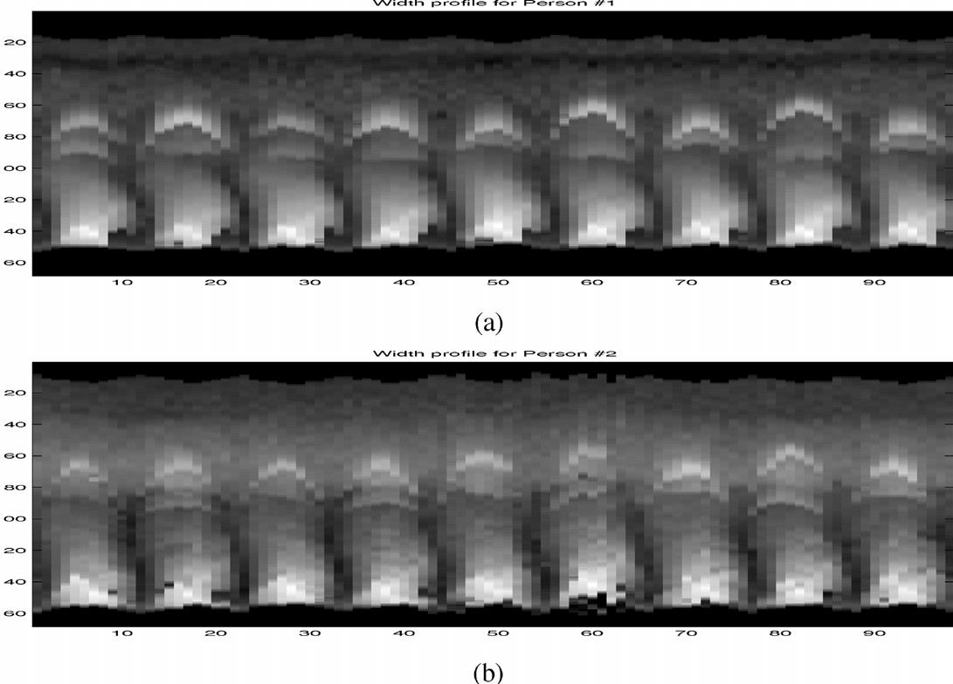

Abstract

We propose a view-based approach to recognize humans from their gait. Two different image features have been considered: the width of the outer contour of the binarized silhouette of the walking person and the entire binary silhouette itself. To obtain the observation vector from the image features, we employ two different methods. In the first method, referred to as the indirect approach, the high- dimensional image feature is transformed to a lower dimensional space by generating what we call the frame to exemplar (FED) distance. The FED vector captures both structural and dynamic traits of each individual. For compact and effective
gait representation and recognition, the gait information in the FED vector sequences is captured in a hidden Markov model (HMM). In the second method, referred to as the direct approach, we work with the feature vector directly (as opposed to computing the FED) and train an HMM. We estimate the HMM parameters (specifically the observation probability ) based on the distance between the exemplars and the image features. In this way, we avoid learning high-dimensional probability density functions. The statistical nature of the HMM lends overall robustness to representation and recognition.

Description of the Problem

An important issue in gait is the extraction of appropriate salient features that will effectively capture the gait characteristics. The features must be reasonably robust to operating conditions and should yield good discriminability across individuals.
As mentioned earlier, we assume that the side view of each individual is available. Intuitively, the silhouette appears to be a good feature to look at as it captures the motion of most of the body parts. It also supports night vision capability as it can be derived from IR imagery also. While extracting this feature we are faced with two options.
- Use the entire silhouette.

- Use only the outer contour of the silhouette.

The choice of using either of the above features depends upon the quality of the binarized silhouettes. If the silhouettes are of good quality, the outer contour retains all the information of the silhouette and allows a representation, the dimension of which is an order of magnitude lower than that of the binarized silhouette. However, for low quality, low resolution data, the extraction of the outer contour from the binarized silhouette may not be reliable. In such situations, direct use of the binarized silhouette may be more appropriate.
We choose the width of the outer contour of the silhouette as one of our feature vectors. In Fig. 1, we show plots of the width profiles of two different individuals for several gait cycles. Since we use only the distance between the left and right extremities of the silhouette, the two halves of the gait cycle are almost indistinguishable. From here on, we refer to half cycles as cycles, for the sake of brevity.

Existing System

There are various biometric based concepts are used in industrial applications for identification of an individual. They are

- Signature verification (ie comparing a 'new' signature or signing with previously enrolled reference information) takes two forms: dynamic signature verification and analysis of a static signature
- Face Recognition method using Laplace faces and also using other methods
- Identification by voice rather than appearance has a long history in literature (a 1930s)
- Iris recognition methods

- Recognition using Digital Signatures

- The existing system has some drawbacks. The problems are:

  - Not unique

  - Easily malpractice can be possible

  - Easily traceable by intruders

  - Low reliability

  - No unique identification

Proposed System

GAIT refers to the style of walking of an individual. Often, in surveillance applications, it is difficult to get face or iris information at the resolution required for recognition. Studies in psychophysics indicate that humans have the capability of

recognizing people from even impoverished displays of gait, indicating the presence of identity information in gaitRecognition on the basis of how an individual walks has attracted interest from defence and other agencies for remote surveillance or infrared recordings of movement in an area under covert surveillance. The technology essentially involves dynamic mapping of the changing relationships of points on a body as that person moves.

Early work from the late 1980s built on biomechanics studies that dated. It centred on the 'stride pattern' of a sideways silhouette, with a few measurement points from the hip to feet. More recent research appears to be encompassing people in the round and seeking to address the challenge of identification in adverse conditions (eg at night, amid smoke or at such a distance that the image quality is very poor).

System Environment

ABOUT SOFTWARE

FRONT END
Python:
Python is a high-level, interpreted, interactive and object-oriented scripting language. Python is designed to be highly readable. It uses English keywords frequently where as other languages use punctuation, and it has fewer syntactical constructions than other languages.
- Python is Interpreted − Python is processed at runtime by the interpreter. You do not need to compile your program before executing it. This is similar to PERL and PHP.
- Python is Interactive − You can actually sit at a Python prompt and interact with the interpreter directly to write your programs.
- Python is Object-Oriented − Python supports Object-Oriented style or technique of programming that encapsulates code within objects.
- Python is a Beginner's Language − Python is a great language for the beginner-level programmers and supports the development of a wide range of applications from simple text processing to WWW browsers to games.
History of Python
Python was developed by Guido van Rossum in the late eighties and early nineties at the National Research Institute for Mathematics and Computer Science in the Netherlands.
Python is derived from many other languages, including ABC, Modula-3, C, C++, Algol-68, SmallTalk, and Unix shell and other scripting languages.
Python is copyrighted. Like Perl, Python source code is now available under the GNU General Public License (GPL).
Python is now maintained by a core development team at the institute, although Guido van Rossum still holds a vital role in directing its progress.
Python Features
Python's features include −
- Easy-to-learn − Python has few keywords, simple structure, and a clearly defined syntax. This allows the student to pick up the language quickly.
- Easy-to-read − Python code is more clearly defined and visible to the eyes.
- Easy-to-maintain − Python's source code is fairly easy-to-maintain.
- A broad standard library − Python's bulk of the library is very portable and cross-platform compatible on UNIX, Windows, and Macintosh.
- Interactive Mode − Python has support for an interactive mode which allows interactive testing and debugging of snippets of code.
- Portable − Python can run on a wide variety of hardware platforms and has the same interface on all platforms.
- Extendable − You can add low-level modules to the Python interpreter. These modules enable programmers to add to or customize their tools to be more efficient.
- Databases − Python provides interfaces to all major commercial databases.
- GUI Programming − Python supports GUI applications that can be created and ported to many system calls, libraries and windows systems, such as Windows MFC, Macintosh, and the X Window system of Unix.
- Scalable − Python provides a better structure and support for large programs than shell scripting.
Apart from the above-mentioned features, Python has a big list of good features, few are listed below −
- It supports functional and structured programming methods as well as OOP.
- It can be used as a scripting language or can be compiled to byte-code for building large applications.
- It provides very high-level dynamic data types and supports dynamic type checking.
- It supports automatic garbage collection.
- It can be easily integrated with C, C++, COM, ActiveX, CORBA, and Java.
Python is available on a wide variety of platforms including Linux and Mac OS X. Let's understand how to set up our Python environment.
Getting Python
The most up-to-date and current source code, binaries, documentation, news, etc., is available on the official website of Python https://www.python.org.
Windows Installation
Here are the steps to install Python on Windows machine.
- Open a Web browser and go to https://www.python.org/downloads/.
- Follow the link for the Windows installer python-XYZ.msifile where XYZ is the version you need to install.
- To use this installer python-XYZ.msi, the Windows system must support Microsoft Installer 2.0. Save the installer file to your local machine and then run it to find out if your machine supports MSI.
- Run the downloaded file. This brings up the Python install wizard, which is really easy to use. Just accept the default settings, wait until the install is finished, and you are done.
The Python language has many similarities to Perl, C, and Java. However, there are some definite differences between the languages.

First Python Program
Let us execute programs in different modes of programming.

Interactive Mode Programming
Invoking the interpreter without passing a script file as a parameter brings up the following prompt −
$ python
Python2.4.3(#1,Nov112010,13:34:43)
[GCC 4.1.220080704(RedHat4.1.2-48)] on linux2
Type"help","copyright","credits"or"license"for more information.
>>>
Type the following text at the Python prompt and press the Enter −
>>>print"Hello, Python!"
If you are running new version of Python, then you would need to use print statement with parenthesis as in print ("Hello, Python!");. However in Python version 2.4.3, this produces the following result −
Hello, Python!

Script Mode Programming
Invoking the interpreter with a script parameter begins execution of the script and continues until the script is finished. When the script is finished, the interpreter is no longer active.
Let us write a simple Python program in a script. Python files have extension .py. Type the following source code in a test.py file −
print"Hello, Python!"
We assume that you have Python interpreter set in PATH variable. Now, try to run this program as follows −
$ python test.py
This produces the following result −
Hello, Python!

Flask Framework:
Flask is a web application framework written in Python. Armin Ronacher, who leads an international group of Python enthusiasts named Pocco, develops it. Flask is based on Werkzeug WSGI toolkit and Jinja2 template engine. Both are Pocco projects.
Http protocol is the foundation of data communication in world wide web. Different methods of data retrieval from specified URL are defined in this protocol.
The following table summarizes different http methods −
Sr.No | Methods & Description
1 | GET  Sends data in unencrypted form to the server. Most common method.
2 | HEAD  Same as GET, but without response body
3 | POST  Used to send HTML form data to server. Data received by POST method is not cached by server.
4 | PUT  Replaces all current representations of the target resource with the uploaded content.
5 | DELETE  Removes all current representations of the target resource given by a URL
By default, the Flask route responds to the GET requests. However, this preference can be altered by providing methods argument to route() decorator.
In order to demonstrate the use of POST method in URL routing, first let us create an HTML form and use the POST method to send form data to a URL.
Save the following script as login.html
<html>
<body>
<formaction="http://localhost:5000/login"method="post">
<p>Enter Name:</p>
<p><inputtype="text"name="nm"/></p>
<p><inputtype="submit"value="submit"/></p>
</form>
</body>
</html>
Now enter the following script in Python shell.
from flask importFlask, redirect,url_for, request
app=Flask(__name__)
@app.route('/success/<name>')
def success(name):
return'welcome %s'% name
@app.route('/login',methods=['POST','GET'])
def login():
ifrequest.method=='POST':
user=request.form['nm']
return redirect(url_for('success',name= user))
else:
user=request.args.get('nm')
return redirect(url_for('success',name= user))
if __name__ =='__main__':
app.run(debug =True)
After the development server starts running, open login.html in the browser, enter name in the text field and click Submit.
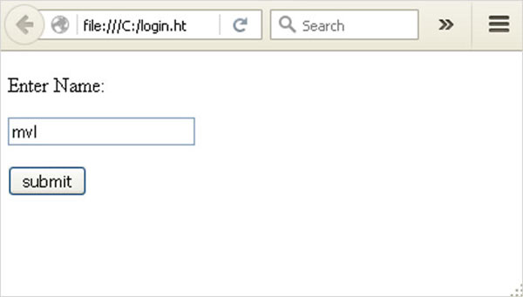
Form data is POSTed to the URL in action clause of form tag.
http://localhost/login is mapped to the login() function. Since the server has received data by POST method, value of ‘nm’ parameter obtained from the form data is obtained by −
user = request.form['nm']
It is passed to ‘/success’ URL as variable part. The browser displays a welcome message in the window.
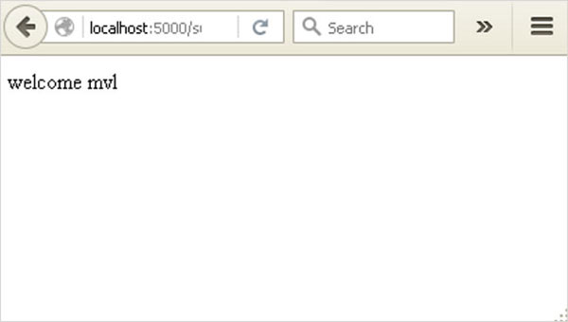
Change the method parameter to ‘GET’ in login.html and open it again in the browser. The data received on server is by the GET method. The value of ‘nm’ parameter is now obtained by −
User = request.args.get(‘nm’)
Here, args is dictionary object containing a list of pairs of form parameter and its corresponding value. The value corresponding to ‘nm’ parameter is passed on to ‘/success’ URL as before.

What is Python?
Python is a popular programming language. It was created in 1991 by Guido van Rossum.
It is used for:
- web development (server-side),
- software development,
- mathematics,
- system scripting.
What can Python do?
- Python can be used on a server to create web applications.
- Python can be used alongside software to create workflows.
- Python can connect to database systems. It can also read and modify files.
- Python can be used to handle big data and perform complex mathematics.
- Python can be used for rapid prototyping, or for production-ready software development.
Why Python?
- Python works on different platforms (Windows, Mac, Linux, Raspberry Pi, etc).
- Python has a simple syntax similar to the English language.
- Python has syntax that allows developers to write programs with fewer lines than some other programming languages.
- Python runs on an interpreter system, meaning that code can be executed as soon as it is written. This means that prototyping can be very quick.
- Python can be treated in a procedural way, an object-orientated way or a functional way.
Good to know
- The most recent major version of Python is Python 3, which we shall be using in this tutorial. However, Python 2, although not being updated with anything other than security updates, is still quite popular.
- In this tutorial Python will be written in a text editor. It is possible to write Python in an Integrated Development Environment, such as Thonny, Pycharm, Netbeans or Eclipse which are particularly useful when managing larger collections of Python files.
Python Syntax compared to other programming languages
- Python was designed to for readability, and has some similarities to the English language with influence from mathematics.
- Python uses new lines to complete a command, as opposed to other programming languages which often use semicolons or parentheses.
- Python relies on indentation, using whitespace, to define scope; such as the scope of loops, functions and classes. Other programming languages often use curly-brackets for this purpose.

BACK END
Many PCs and Macs will have python already installed.
To check if you have python installed on a Windows PC, search in the start bar for Python or run the following on the Command Line (cmd.exe):
C:\Users\Your Name>python --version
To check if you have python installed on a Linux or Mac, then on linux open the command line or on Mac open the Terminal and type:
python --version
If you find that you do not have python installed on your computer, then you can download it for free from the following website: https://www.python.org/

Python Quickstart
Python is an interpreted programming language, this means that as a developer you write Python (.py) files in a text editor and then put those files into the python interpreter to be executed.
The way to run a python file is like this on the command line:
C:\Users\Your Name>python helloworld.py
Where "helloworld.py" is the name of your python file.
Let's write our first Python file, called helloworld.py, which can be done in any text editor.
helloworld.py
print("Hello, World!")
Simple as that. Save your file. Open your command line, navigate to the directory where you saved your file, and run:
C:\Users\Your Name>python helloworld.py
The output should read:
Hello, World!
Congratulations, you have written and executed your first Python program.

The Python Command Line
To test a short amount of code in python sometimes it is quickest and easiest not to write the code in a file. This is made possible because Python can be run as a command line itself.
Type the following on the Windows, Mac or Linux command line:
C:\Users\Your Name>python
From there you can write any python, including our hello world example from earlier in the tutorial:
C:\Users\Your Name>python
Python 3.6.4 (v3.6.4:d48eceb, Dec 19 2017, 06:04:45) [MSC v.1900 32 bit (Intel)] on win32
Type "help", "copyright", "credits" or "license" for more information.
>>> print("Hello, World!")
Which will write "Hello, World!" in the command line:
C:\Users\Your Name>python
Python 3.6.4 (v3.6.4:d48eceb, Dec 19 2017, 06:04:45) [MSC v.1900 32 bit (Intel)] on win32
Type "help", "copyright", "credits" or "license" for more information.
>>> print("Hello, World!")
Hello, World!
Whenever you are done in the python command line, you can simply type the following to quit the python command line interface:
exit()
Execute Python Syntax
As we learned in the previous page, Python syntax can be executed by writing directly in the Command Line:
>>> print("Hello, World!")
Hello, World!
Or by creating a python file on the server, using the .py file extension, and running it in the Command Line:
C:\Users\Your Name>python myfile.py

Python Indentations
Where in other programming languages the indentation in code is for readability only, in Python the indentation is very important.
Python uses indentation to indicate a block of code.
Example
if 5 > 2:
print("Five is greater than two!")
Python will give you an error if you skip the indentation:
Example
if 5 > 2:
print("Five is greater than two!")

Comments
Python has commenting capability for the purpose of in-code documentation.
Comments start with a #, and Python will render the rest of the line as a comment:
Example
Comments in Python:
#This is a comment.
print("Hello, World!")
Docstrings
Python also has extended documentation capability, called docstrings.
Docstrings can be one line, or multiline.
Python uses triple quotes at the beginning and end of the docstring:
Example
Docstrings are also comments:
"""This is a
multiline docstring."""
print("Hello, World!")

System Requirement

Hardware specifications:

Processor : Intel Processor IV

RAM : 128 MB

Hard disk : 20 GB

CD drive : 40 x Samsung

Floppy drive : 1.44 MB

Monitor : 15’ Samtron color

Keyboard : 108 mercury keyboard

Mouse : Logitech mouse

Software Specification

Operating System – Windows =
Language used – Python

System Analysis

System analysis can be defined, as a method that is determined to use the resources, machine in the best manner and perform tasks to meet the information needs of an organization.

System Description

It is also a management technique that helps us in designing a new systems or improving an existing system. The four basic elements in the system analysis are
    - Output

    - Input

    - Files

    - Process

The above-mentioned are mentioned are the four basis of the System Analysis.

Proposed System Description

Given the image sequence of a subject, the width vectors are generated as follows.

- Background subtraction is first applied to the image sequence. The resultant motion image is then binarized into foreground and background pixels.
- A bounding box is then placed around the part of the motion image that contains the moving person. The size of the box is chosen to accommodate all the individuals in the database. These boxed binarized silhouettes can be used directly as image features or further processed to derive the width vector as in the next item.
- Given the binarized silhouettes, the left and right boundaries of the body are traced. The width of the silhouette along each rowof the image is then stored. The width along a given row is simply the difference in the locations of the right-most and the left-most boundary pixels in that row. In order to generate the binarized silhouette only, the first two steps of the above feature are used. One of the direct applications of the width feature is to parse the video into cycles in order to compute the exemplars. It is easy to see that the norm of the width vector show a periodic variation. Fig. 2 shows the norm of the width vector as a function of time for a given video sequence. The valleys of the resultingwaveform correspond to the rest positions during the walk cycle while the peaks correspond to the part of the cycle where the hands and legs are maximally displaced.

Given a sequence of image features for person j,

X j = { X j (1), X j (1), ……………… X j (T) }

we wish to build a model for the gait of person and use it to recognize this person from different subjects in the database.

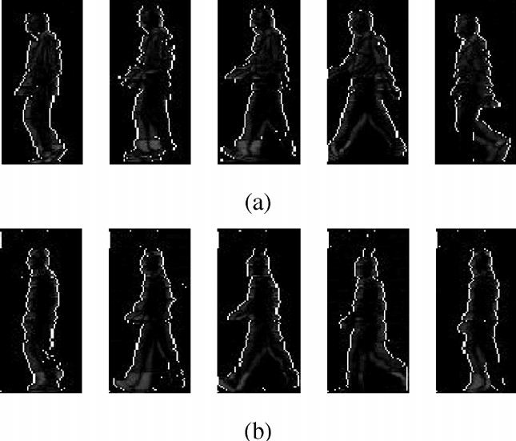

Fig 3. Stances corresponding to the gait cycle of two individuals.

(a) Person 1(b) Person 2.

Gait Representation: In this approach, we pick N exemplars (or stances)

€ = { e1, e2………………..en }

from the pool of images that will minimize the error in representation of all the images of that person. If the overall average distortion is used as a criterion for codebook design, the selection of the N exemplars is said to be optimal if the overall average distortion is minimized for that choice. There are two conditions for ensuring

optimality. The first condition is that the optimal quantizer is realized by using a nearest neighbor selection rule
q ( X) = ei implies that d ( X, ei ) <= d(X,ej ) , j not equal to i and 1 <= i , j <= N

where represents an image in the training set, d ( X, ei ) is the distance between X , and ei , while N is the number of exemplars The second condition for optimality is that each codeword/exemplar ei is chosen to minimize the average distortion in the cell Ci, i.e.
ei = arg min e E ( d(X, e) X belongs to Ci )

where the Ci s represent the Voronoi partitions across the set of training images. To iteratively minimize the average distortion measure, the most widely used method is the K–means algorithm. However, implementing the K -means algorithm raises a number of issues. It is difficult to maintain a temporal order of the centroids (i.e., exemplars) automatically. Even if the order is maintained, there could be a cyclical shift in the centroids due to phase shifts in the gait cycle (i.e., different starting positions). In order to alleviate these problems, we divide each gait cycle into N equal segments. We pool the image features corresponding to the th segment for all N the cycles. The centroids (essentially the mean) of the features of each part were computed and denoted as the exemplar for that part. Doing this for all the N segments gives the optimal exemplar set
€ = { e1 *, e2 *………………..en * }

Of course, there is the issue of picking N. This is the classical problem of choosing the appropriate dimensionality of a model that will fit a given set of observations, e.g choice of degree for a polynomial regression.
The application is implemented with Training and Test data sets. The training to gain knowledge as it is of the form unsupervised learning algorithm.
Unsupervised learning - this is learning from observation and discovery. The data mining system is supplied with objects but no classes are defined so it has to observe the examples and recognize patterns (i.e. class description) by itself. This system results in a set of class descriptions, one for each class discovered in the environment. Again this is similar to cluster analysis as in statistics.
After the training process the system should gained the knowledge and then the Test process is called to identify the human based on the given input.

5. System Design

Design is concerned with identifying software components specifying relationships among components. Specifying software structure and providing blue print for the document phase.
Modularity is one of the desirable properties of large systems. It implies that the system is divided into several parts. In such a manner, the interaction between parts is minimal clearly specified.
Design will explain software components in detail. This will help the implementation of the system. Moreover, this will guide the further changes in the system to satisfy the future requirements.

Form design

Form is a tool with a message; it is the physical carrier of data or information.

Input design

Inaccurate input data is the most common case of errors in data processing. Errors entered by data entry operators can control by input design. Input design is the process of converting user-originated inputs to a computer-based format. Input data are collected and organized into group of similar data.

Code Design

The entire application is divided into five modules as follows:

    - Video Capture and Framing:

      - captures video of persons walking and performs file operations on video files for extracting the sequence of frames from the video.

    - Motion Detection:

      - apply motion detection algorithms to detect any moving object(s) in the video and identify the object to classify as humans.

    - Image File Processing:

      - performs image operations such as reading/writing and other pre- processing algorithms such as edge-finding, binarizing, thinning, etc.

    - Gait Representation:

      - obtains representation models for silhouettes extracted from the results of image processing algorithms, and apply the feature extraction steps for storing the features (fed vectors) into the database. fed is frame-to- exemplar-distance which is extracted from whole gait cycles from the input video.

    - Gait Recognition:

      - here the input video is applied to the above algorithms and compared with the stored features to find the best match.

6. Output Design

6.1Forms and Reports

Forms
The user interface form designed in java Swing Frame that accept the input image as PGM image from the path \frames\test\ folder. The images that you want to test to be stored in this folder. The application is designed to retrieve input image from here.

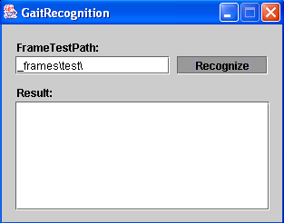

Then click the Recognize Button. That in term invokes the Training module.

The application is implemented in the K means algorithm as discussed in section 4.

First the training process is called knowledge is gained here by the system. Then it calls the Test process is done with the input image and the following results were displayed to the user.

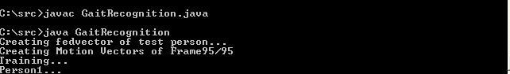

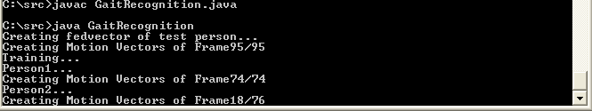

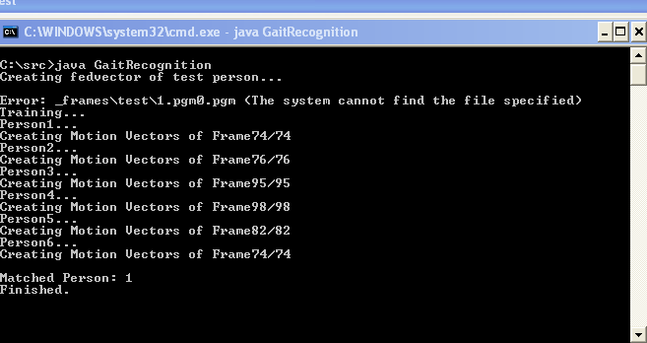

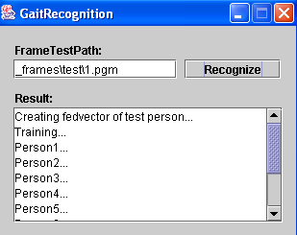

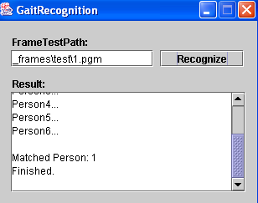

Testing and Implementation

Software Testing

Software Testing is the process of confirming the functionality and correctness of software by running it. Software testing is usually performed for one of two reasons:

    - Defect detection

    - Reliability estimation.

White box testing is concerned only with testing the software product, it cannot guarantee that the complete specification has been implemented. Black box testing is concerned only with testing the specification, it cannot guarantee that all parts of the implementation have been tested. Thus black box testing is testing against the specification and will discover faults of omission, indicating that part of the specification has not been fulfilled. White box testing is testing against the implementation and will discover faults of commission, indicating that part of the implementation is faulty. In order to fully test a software product both black and white box testing are required
The problem of applying software testing to defect detection is that software can only suggest the presence of flaws, not their absence (unless the testing is exhaustive). The problem of applying software testing to reliability estimation is that the input distribution used for selecting test cases may be flawed. In both of these cases, the mechanism used to determine whether program output is correct is often

impossible to develop. Obviously the benefit of the entire software testing process is highly dependent on many different pieces. If any of these parts is faulty, the entire process is compromised.

Software is now unique unlike other physical processes where inputs are received and outputs are produced. Where software differs is in the manner in which it fails. Most physical systems fail in a fixed (and reasonably small) set of ways. By contrast, software can fail in many bizarre ways. Detecting all of the different failure modes for software is generally infeasible.

`The key to software testing is trying to find the myriad of failure modes – something that requires exhaustively testing the code on all possible inputs. For most programs, this is computationally infeasible. It is commonplace to attempt to test as many of the syntactic features of the code as possible (within some set of resource constraints) are called white box software testing technique. Techniques that do not consider the code’s structure when test cases are selected are called black box technique.

Functional testing is a testing process that is black box in nature. It is aimed at examine the overall functionality of the product. It usually includes testing of all the interfaces and should therefore involve the clients in the process.

Final stage of the testing process should be System Testing. This type of test involves examination of the whole computer system, all the software components, all the hard ware components and any interfaces.

The whole computer based system is checked not only for validity but also to meet the objectives.

7.2 Implementation

Implementation includes all those activities that take place to convert from the old system to the new. The new system may be totally new, replacing an existing system or it may be major modification to the system currently put into use. This application is taken the input image from user. The implemented in the form of training and test process as discussed in Unsupervised learning algorithm. The algorithm is implemented with help of K means algorithm . The input images were read as PGM images. The separate class is written to read and write the PGM image.

Conclusion

We have presented two approaches to represent and recognize people by their gait. The width of the outer contour of the binarized silhouette as well as the silhouette itself were used as features to represent gait. In one approach, a low- dimensional observation sequence is derived from the silhouettes during a gait cycle and an HMM is trained for each person. Gait identification is performed by evaluating the probability that a given observation sequence was generated by a particular HMM model. In the second approach, the distance between an image feature and exemplar was used to estimate the observation probability . The performance of the methods was illustrated using different gait databases

Bibliography

Appendix

